HOUSE RULES for the Vrisoules holiday resort
We warmly welcome you to our “Vrisoules Pool Villa” and hope that you have a relaxing holiday in our resort.
Our experience has shown that certain rules for dealing with the facility make sense in order to make your stay with us as carefree as possible and to avoid any misunderstandings in advance.
INTENDED USE
The facility is used exclusively for holiday and recovery purposes for the people listed when booking.
CHECK IN/OUT
Check-in 3:00 p.m., check-out 12:00 p.m.
Other arrival times must be communicated to us or agreed upon. We will provide you with two sets of house keys, including a radio remote control for the automatic entrance gate, for the duration of your stay.
SMOKE
Smoking is prohibited in all rooms in our holiday home. Please only use the outdoor area of ​​our facility to smoke.
INVENTORY AND DAMAGES
We ask that you handle our inventory and fixtures (indoor and outdoor) with care. Damage to furniture and furnishings occurs and is often easy to repair. Please inform us of any damage caused. Tenants and fellow travelers are liable for any damage they cause.
CLEANING AND GARBAGE
The house will be thoroughly cleaned before your arrival. Daily cleaning of the holiday home is not included. The resulting rubbish must be disposed of in the green rubbish bin in front of the house. We will ensure further emptying.
AIR CONDITION
We ask that you do not use the air conditioning when you are not present or when the windows/doors are open.
LAUNDRY
Bed linen and towels, depending on the number of guests booked, are provided and changed once a week.
SAFETY AND VALUABLES
Always close all windows and doors before leaving the holiday home. We assume no liability for the loss of valuables during your stay.
POOL
Our guests use the pool at their own risk. Parents are responsible for their children. Our pool has a water depth of approx. 1.6m and is unsuitable for non-swimmers, depending on your body size. We would also like to point out the increased risk of slipping within the pool area. The water must be protected from any contamination.
BBQ/OPEN FIRE
It is officially forbidden to light open fires in the summer. The grill station in the pool area must therefore only be used with commercially available charcoal and appropriate charcoal lighters.
PARKING SPOT
Your vehicles must be parked in the designated parking spaces within the facility.
PLANTING
The pool area is planted with tropical plants, mainly palm trees and other garden plants. Please be careful with our garden.
VOLUME
Please be considerate of our neighbors and keep the volume to a moderate level in the complex, especially when it comes to music or TV.
VISITORS
Guests not listed when booking are not allowed into the facility.
PETS
Pets can only be taken on request.
EMERGENCY CONTACT:
Landlord: +436643006306
if unavailable:
House technician: +306932370233
office@vrisoules.com
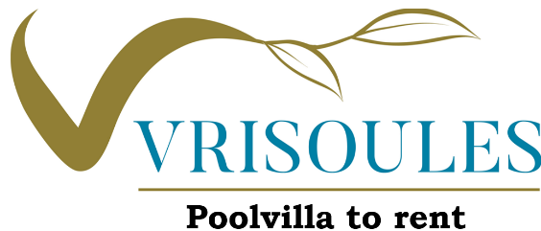
Please contact us if you have any other questions or concerns.
We will find a solution for almost every problem or wishes.

